***Documentation***

**Title: Kosovo Cyber Team**

**Project description:**

The Kosovo Cyber Team was a national initiative that brought together students, young professionals, and cybersecurity enthusiasts to advance cybersecurity knowledge and skills in Kosovo. The team focused on building a collaborative community that promoted education, awareness, and innovation in cybersecurity. Through activities such as training, workshops, and competitions, it equipped members with practical experience and technical expertise. The Kosovo Cyber Team also represented the country in international competitions, including the European Cybersecurity Challenge (ECSC), where they competed and showcased their skills on a continental stage, contributing to Kosovo's growing cybersecurity ecosystem.

We were here as a fiscal sponsor

**Activities:**Key activities:

* Organized workshops that facilitated hands-on experience in tackling cybersecurity challenges.
* Conducted multiple training sessions on various cybersecurity topics to enhance participants' skills.
* Developed partnerships with local and international organizations to strengthen community engagement and resource sharing.
* Held competitions to promote friendly rivalry and practical application of cybersecurity knowledge.

**Photos:**

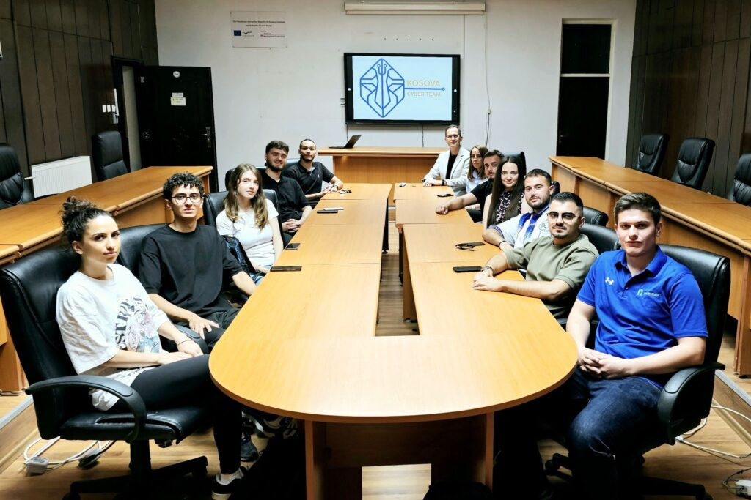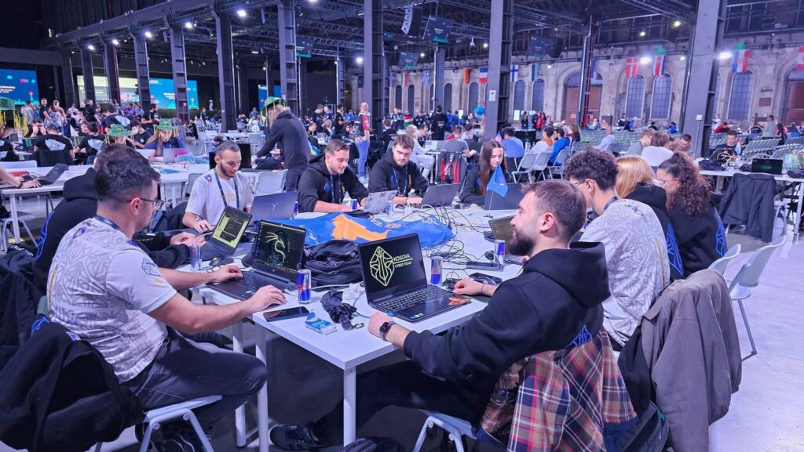

**Beneficiaries:**

Participants from universities and technical schools across Kosovo benefited from the skills development and networking opportunities provided by the Kosovo Cyber Team.

**Partners:**

* N/A

**Budget:  
€15,100.00**

**Project duration**:

*August 2024 – December 2024*

*This document is FLOSSK intellectual property - Do not share without authorization from FLOSSK.*